The Bilge Pump  Vol. 01, No. 04 – September, 2013  The Irregular Publication of the Crew of the Barque Lone Star |  | 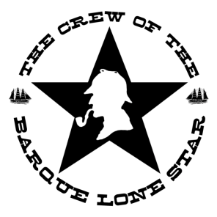
From the Editors: Along with the newsletter itself, we are attaching another pastiche written by Jack Brazos III and provided to us by his literary agent, Marland Henderson, titled THE MYSTERIOUS KIDNAPPING OF OLD WIDOW JONES.
In this month, we will also provide a review of the Sherlock Holmes Conference held in Minnesota.
Don, Steve, & Joe
October, 2013 Meeting  The next meeting will be held on Sunday, October 6, at McFadden’s in Addison.  “The Adventure of the Speckled Band,” which was considered Doyle’s favorite Holmesian story, will be discussed. A quiz on the reading will be conducted at the beginning of the meeting.  Joe Fay will provide a short discussion on Mormons (to close out A Study in Scarlet,), and Tim Kline will give a presentation on the games of Sherlock Holmes.  Each monthly meeting will also include appropriate toasts as well as general business, introductions, and general fellowship.  Remember to bring books you no longer  want for the book exchange !! | September, 2013 Meeting  The last meeting was held on September 1, with 15 members in attendance. The opening toast was presented by Jim Webb to Jefferson Hope, who pursued the killers of his beloved Lucy for over 20 years.  Don Hobbs provided a short summary of the Minnesota conference (see Page 3 for more details).  More discussion was held on the idea of holding a conference in Texas. We are tentatively now looking at holding it in conjunction with the International Sherlock Holmes Exhibit, which will be at the Perot Science Museum, from February – May, 2015. A suggested working title for the conference would be, “Sherlock: Deep in the Heart of Texas.” Jim Webb suggested focusing on the science of Sherlock Holmes, to tie into the museum exhibition.  The monthly quiz covered Part 2, chapters 1-7 of A Study in Scarlet. Brenda Hutchinson and Sharon Lowry tied for first place on the quiz.  We relived the old game show “Password”, using words from the Canon titles as the answers. Our spiritual advisors, Mr. Hobbs and Mr. Webb did an excellent job in doling out the clues to the various contestants.  Walter Pieper gave the closing toast, reciting a poem from William B. Schweickert, "A Long Evening with Holmes." (see page 2).
For more information concerning our society, visit: http://barquelonestar.com/
You can follow us on Twitter at: @barquelonestar

You can friend us on Facebook at: http://www.facebook.com/BarqueLoneStar

John Dickson Carr and Doyle -- Baker Street Journal Excerpt – Editor’s Gas Lamp, January, 1949
B AKER STREET IRREGULARS everywhere will note in February, 1949, the publication of John Dickson Carr’s authoritative biography of Sherlock Holmes’s great and good friend Sir Arthur Conan Doyle.’

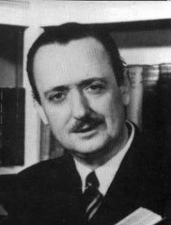  Mr. Carr has told the story of this many-sided man—for whom, be it said, no group has a higher admiration than the Irregulars themselves—better than anyone has told it before. It is a biography, happily, and not an autobiography; and it is, as might therefore be expected, more discerning and in better perspective than Dr. Doyle’s own Memories and Adventures.  Mr. Carr worked from the massive documentation made available to him by the Doyle estate out of a cache of trunks and boxes which had lain untouched since Sir Arthur’s death in 1930—a vast accumulation of letters, notes, diaries, commonplace books and collateral data into which had been frozen, as well as such a thing can happen, a reflection of the thoughts and deeds, the elusive purposes and emotions, of a dynamic human being.  What emerges is what a biography ought, after all, to be—the story of a man’s life.  And it is worth much; for Conan Doyle was a giant of a man in every way—a simple giant, admittedly, and a gentle one, but a | giant still; conscious of his strength as it grew upon him, and boyishly eager to flex his moral and his mental muscles and to use them in every just cause.  How challenging and absorbing those causes were, and how bravely this Victorian Sir Arthur drew his sword Exealibur in their defense! Each campaign he undertook became, as long as it lasted, the only thing in the world that mattered. And always he wrote— wrote—wrote, with a fervor as prodigious as his zest for life and living, and with a sense of righteousness and justice so wholesome and so profound that it bordered upon the smug.  Doyle was a great sportsman, a great patriot, a great crusader, a great writer. He was, above all, a great historical novelist: The White Company is still one of the best three or four books that have been written in its field.  Dr. Watson’s saga of Sherlock Holmes reflects the aura of London and of London’s England in the Nineties.  There will be, surely, no readers of the Sherlock Holmes tales who will not wish also to read this life of a man who walked and talked with Sherlock Holmes.
A Long Evening with Holmes  William B. Schweickert  When the world closes in with its worries and cares  And my problems and headaches are coming in pairs  I just climb in my mind those seventeen stairs  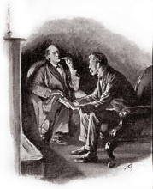  And spend a long evening with Holmes.  The good Doctor greets me and motions me in  Holmes grasps my hand and lays down his violin  Then we sit by the fire and sip a tall gin  When I spend a long evening with Holmes.  And while we're discussing his cases galore  If I'm lucky there comes a loud knock on the door  In stumbles a client, head splattered with gore  When I spend a long evening with Holmes. | Watson binds up the client's poor face  While Holmes soon extracts all the facts of the case  Then off in a hansom to Brixton we race  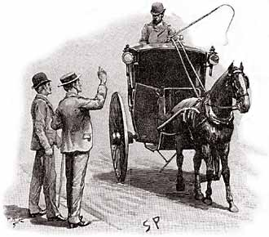  When I spend a long evening with Holmes.  The Adventure is solved, Holmes makes it all right  So back to the lodgings by dawn's early light  And a breakfast by Hudson to wind up the night  When I spend a long evening with Holmes.  So the modern rat race can't keep me in a cage  I have a passport to a far better age  As close as my bookcase, as near as a page  I can spend a long evening with Holmes.

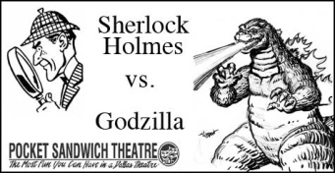
Sherlock Holmes vs. Godzilla
On August 17, five of our more courageous members attended the late night showing of the melodrama, Sherlock Holmes vs. Godzilla at the Pocket Sandwich Theatre in Dallas.  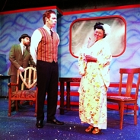  In this spoofilicious comedy by Dallas producer/author/actor Benjamin Schroth, Sherlock Holmes and his loyal sidekick Dr. John Watson fight the greatest evil yet. Time travel, a fictional giant lizard and a villain from drive-in movies challenge our deductive hero with evil and seduction of every stripe. |  | 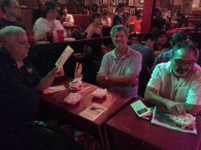  Watson helps as best he can but is distracted by the call of the wild in the form of both automaton seductresses and an unwillingly cross-dressed assistant. In the end, Holmes must face Godzilla and his own gooey inner demons to save the world from its farcical fate. It is no easy feat to maintain one’s character while being swatted with kernels of popcorn, but the Pocket casts consistently do so with seasoned skill.
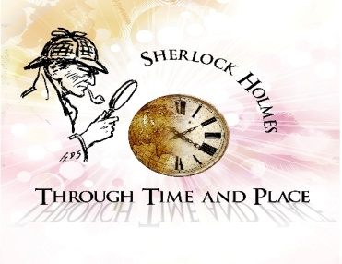 | On August 9-11, 2013, The Norwegian Explorers of Minnesota and the Friends of the Sherlock Holmes Collections at the University of Minnesota held a conference to explore aspects of Sherlock Holmes Through Time and Place.  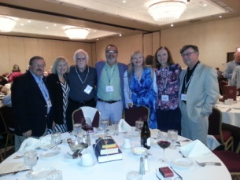  The conference featured presentations by an amazing group of international Sherlockians (including our own Don Hobbs), vendor tables, a silent auction, a dramatic performance by the Red-Throated League of the Norwegian Explorers, and the Annual Meeting of the Friends of the Sherlock Holmes Collections.
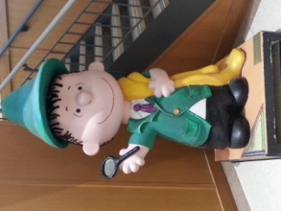
A few of us were also privileged to take a tour of the Sherlock Holmes Special Collection at the Library, which includes the John Bennett Shaw collection, several Beeton’s Christmas Annuals (A Study in Scarlet), and 2 pages of original manuscript from the Hound of the Baskervilles.
To give you a flavor of the topics covered during the conference:
The first talk of the conference was by Chris Redmond, with the title "Why the Carbuncle was Blue and the Dragon was Green: Colors, Feels and Themes for Perceptive Readers.
Marcus Geisser gave the second talk of the conference, "Travel in the Blood is Likely to Lead to the Most Exotic Destinations: Some Sigersonian Reflections."
Guy Marriott, the president of the Sherlock Holmes Society of London, provided a talk “Sherlock Holmes and the London Underground," concerning trains and stations.  The banquet speaker was Les Klinger. He addressed his start with Sherlock, as well as the lawsuit on copyrights.  "Sherlock Holmes in the Proper Time and Place" was presented by Mike Eckman, who questioned how Holmes would have fared in the modern world?  On Saturday morning, Don Hobbs, provided insights into the collecting world, including his own pursuit of foreign translations of the canon. The title of his talk was "The Collection Mania in its Most Acute Form."  Bill Mason, Nashville, gave a presentation entitled "Masters of the Victorian Underworld: Holmes, Moriarty and the Criminal Class." He argued Holmes had no contact with a lowbrow |  | 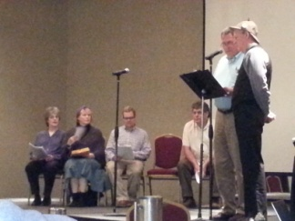  murderer like Jack the Ripper, but focused on those cases which held his interest.  The last presentation on Saturday was by Mattias Bostrom on "How Sherlock Holmes Conquered Scandinavia." Scandinavian countries did not sign the Berne Convention of 1886, which established international copyright. Therefore, Scandinavian publishers could publish ACD stories very cheaply, only paying for a translator and a cover illustrator.  The final event was a presentation by "The Red-Throated League," of the Norwegian Explorers of the play “Monster of Gyre,” a script by Edith Meiser.
Thanks to Karen Murdock of the Norwegian Explorers for her wonderful reporting of the conference in the “Hounds of the Internet,” where much of this information was gleamed.

Physicians and Surgeons (from the Baker Street Journal, January, 1955)
All you have to do is to match the doctor in each of the following cases:
- This famous surgeon treated the Master for two scalp wounds and many bruises. | Dr. Percy Trevelyan
- During a train journey, he was of great service to a young man who had suffered a fit in Waterloo Station. | Dr. Willows
- This chess-playing doctor and a lady were locked in a small room and gassed. | Dr. James Mortimer
- Having gone to the laboratory to bring medicine for a supposed cataleptic, he returned to his office to find the patient had disappeared. | Dr. Grimesby Roylott
- He was head of the medical school of the University, and considered a thinker of European reputation in more than one branch of science | Sir James Saunders
- Arriving at the murder scene after the crime had been committed, he remarked that the injuries made on the victim were some of the most horrible he had ever seen, since a terrible railway accident. | Dr. Ray Ernest
- This house surgeon won a prize for writing an essay entitled "Is Disease a Reversion?" | Sir Leslie Oakshott
- Once a skillful physician, he became the terror of his village, where residents would fly at his approach. | Dr. Leslie Armstrong
- A specialist in tropical diseases, he brought welcome news to a distressed family. | Dr. Wood
- He diagnosed the illness of a dying murderer as diabetes and a shattered nervous system. | Dr. Ferrier
Answers will be in next month’s Newsletter…

The Master of the House – Answers (from August, 2013 Bilge Newsletter)

Listed on the left are the names of 20 famous Holmesian Homes. On the right are the men who ruled over them. See how many you can match up.
 | Abbey Grange | Charles McCarthy | 9
 | Appledore Towers | Sir Eustace Brackenstall | 1
 | Birlstone Manor House | Professor Coram | 20
 | Briarbrae | Hilton Cubitt | 13
 | Charlington Hall | John Douglas | 3
 | Cheeseman’s | Colonel Emsworth | 16
 | Copper Beeches | Robert Ferguson | 6
 | Deep Dene House | Mr. Frankland | 10
 | Hatherley Farmhouse | Aloysius Garcia | 18
 | Lafter Hall | J. Neil Gibson | 15
 | Manor House of Hurlstone | Baron Adelbert Gruner | 17
 | Pondicherry Lodge | Charles Augustus Milverton | 2
 | Ridling Thorpe Manor | Reginald Musgrave | 11
 | Stoke Moran Manor House | Jonas Oldacre | 8
 | Thor Place | Mr. Phelps | 4
 | Tuxbury Old Hall | Dr. Grimesby Roylott | 14
 | Vernon Lodge | Captain Peter Carey | 19
 | Wisteria Lodge | Jephro Rucastle | 7
 | Woodman’s Lee | Bartholomew Sholto | 12
 | Yoxley Old Place | Mr. Williamson | 5
From the Baker Street Journal, October, 1951

Who dunnit: | Third Mate  Helmsman  Spiritual Advisors  Secretaries | Steve Mason  mason.steve@epa.gov  Joe Fay  joef@HA.com  Don Hobbs, BSI  221b@verizon.net  Jim Webb  jimrwebb@ix.netcom.com  Cindy Brown  Pam Mason

